
CONSULTATION RESPONSE

Third State Pension age review: independent report call for evidence

Introduction
Established by the Commissioner for Older People (Wales) Act 2006 which sets out details of the Commissioner’s role and statutory powers, the Older People’s Commissioner for Wales is an independent voice and champion for older people throughout Wales. The role of the Commissioner is to promote awareness of the rights and interests of older people in Wales, challenge discrimination, encourage best practice and review the law affecting the interests of older people in Wales.
The Commissioner was pleased to meet with Dr Suzy Morrissey on 13 October 2025 to discuss issues relating to the Independent Review, especially those specific to Wales.
In addition to the meeting discussion, the Commissioner would like to emphasise the points below.
Life expectancy
Improvements to life expectancy have not materialised to the extent of previous predictions. People’s ability to work into later life is impacted by healthy life expectancy, with some types of occupations making it more difficult to continue. These can include manual trades, for instance. People who would have reached the earlier State Pension age can find themselves moving on to working age benefits and there is a rise in the number of people over 65 in incapacity benefit caseloads.
Using life expectancy as a basis for State Pension age does not take account of the fact that many people become too ill to work. Similarly, medical advances might mean that more people are living longer but in poorer health – living longer does not automatically mean people’s working lives can be extended.
In Wales, life expectancy is 78 for males and 82 for females (slightly lower than the average for England and Wales of 79 and 83). Healthy life expectancy is just 61 for men and 60 for women, which means on average people are spending around a quarter of their life in poor health. There are significant differences between healthy life expectancy in different parts of Wales: in Blaenau Gwent these figures are 59.5 for men and 59.3 for women, while in neighbouring Monmouthshire, less than an hour's drive away, they are 69.8 and 70.1 respectively. This stark difference demonstrates the impact of the wider determinants of health that lead to health inequalities.
While, the latest UK 2022-based cohort life expectancy projections show improvements in life expectancy, these are lower than forecasted in previous data releases.

Employment rate and incapacity benefits
Latest figures show that during 2024-25 employment rates for people aged 50-64 were lower in Wales than in all other parts of the UK, and more than 10% lower than in some areas. 63.9% of this age group are in employment in Wales.
The Office for Budget Responsibility estimates an increase of 330,000 caseload increases of incapacity benefits between 2008-9 and 2023-24. These are in women over 60, and men over 65, coinciding with the rising pension age. As noted above, people who would have reached the previous State Pension age can find themselves moving on to working age benefits rather than being able to work additional years.
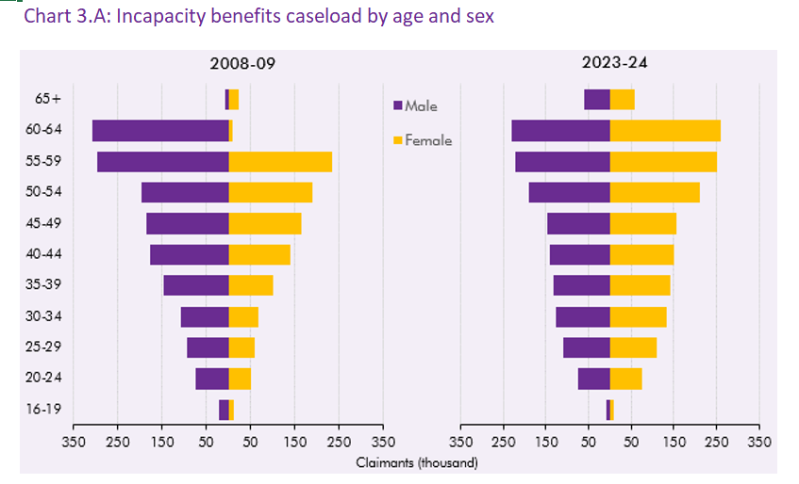

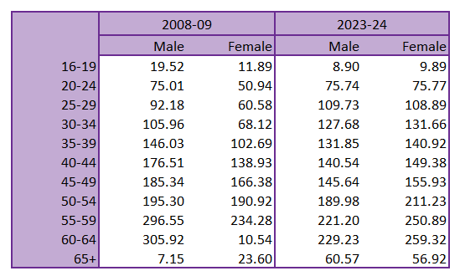

Unpaid carers
A significant number of older people in Wales – around 275,000 – provide unpaid care, making up over half of all unpaid carers. Older people are also more likely to be providing care for more than 50 hours a week: 33% of people aged 75+ and 21% of people aged 65-74 provide this level of care. This impacts on older people’s capacity to undertake paid work with consequences for income in later life.
Automatic Adjustment Mechanisms (AAMs)
The Commissioner has concerns about the introduction of predefined rules that automatically change established State Pension age, particularly where these are used to link State Pension age to life expectancy, given the significant differences between life expectancy and health life expectancy.
In addition to the issues highlighted above, any consideration of AAMS must fully take into account the impact on people’s ability to plan for retirement and later life. The ongoing example of the WASPI (Women Against State Pension Inequality) women is an illustration of the consequences for individuals of failing to communicate adequately with consequences for planning for retirement.

Ageism
There is a need to ensure that narratives of intergenerational fairness around the future of State Pension provision do not unintentionally promote or encourage ageism – stereotypes of ‘rich pensioners’ hide the fact that nearly 1 in 6 older people in Wales live in relative income poverty (16%). This proportion rises with age.
The World Health Organisation’s Global Report on Ageism from 2021 noted that 1 in 2 people worldwide are ageist and that in Europe, 1 in 3 older people report having been a target of ageism.

Conclusion
Within the terms of the current Review, it is vital to emphasise the limitations and risks of overly focusing on life expectancy as opposed to healthy life expectancy when considering any changes to State Pension age in the future. Healthy life expectancy varies considerably within nations and regions as well as between them, impacting people’s ability to work as we get older.
The Review should form part of a wider discussion of the action needed to reduce health inequalities and opportunities for a renewed focus on this.
Lastly, the Review should take every chance to challenge ageism, ensuring that discussions of intergenerational fairness do not inadvertently embed unhelpful stereotypes of older people.

Older People’s Commissioner for Wales (2025), Growing Older in Wales. Available at: https://olderpeople.wales/wp-content/uploads/2025/09/Growing-Older-in-Wales-A-Snapshot-of-Older-Peoples-Experiences.pdf, page 6.
Department for Work and Pensions, Uk Government (2025), Third State Pension Review: Independent report call for evidence. Available at: https://www.gov.uk/government/calls-for-evidence/third-state-pension-age-review-independent-report-call-for-evidence/third-state-pension-age-review-independent-report-call-for-evidence#policy-context
Older People’s Commissioner for Wales (2025), Growing Older in Wales. Available at: https://olderpeople.wales/wp-content/uploads/2025/09/Growing-Older-in-Wales-A-Snapshot-of-Older-Peoples-Experiences.pdf, page 20
Office for Budget Responsibility, Welfare Trends Report (October 2024) Welfare trends report – October 2024: Charts and Tables https://obr.uk/wtr/welfare-trends-report-october-2024/
Older People’s Commissioner for Wales (2025), Growing Older in Wales. Available at: https://olderpeople.wales/wp-content/uploads/2025/09/Growing-Older-in-Wales-A-Snapshot-of-Older-Peoples-Experiences.pdf, page 22.
Older People’s Commissioner for Wales (2025), Understanding Wales’s Ageing Population. Available at: https://olderpeople.wales/wp-content/uploads/2024/09/Understanding-Wales-ageing-population-September-24.pdf
Older People’s Commissioner for Wales (2025), Understanding Wales’s Ageing Population. Available at: https://olderpeople.wales/wp-content/uploads/2024/09/Understanding-Wales-ageing-population-September-24.pdf

